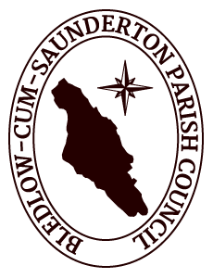
BLEDLOW-CUM-SAUNDERTON PARISH COUNCIL

Notice of public rights and publication of unaudited annual governance & accountability return

Accounts for the year ended 31st March 2019

The Local Audit and Accountability Act 2014 Sections 26 and 27
The Accounts and Audit (England) Regulations 2015 (SI 234)

- Date of announcement: 26th June 2019

- Each year the smaller authority’s Annual Governance and Accountability Return (AGAR) needs to be reviewed by an external auditor appointed by Smaller Authorities’ Audit Appointments Ltd. The unaudited AGAR has been published with this notice. As it has yet to be reviewed by the appointed auditor, it is subject to change as a result of that review.

Any person interested has the right to inspect and make copies of the accounting records for the financial year to which the audit relates and all books, deeds, contracts, bills, vouchers, receipts and other documents relating to those records must be made available for inspection by any person interested. For the year ended March 31st 2019, these documents will be available on reasonable notice by application to:

Tracey Martin, Clerk to the Parish Council

2 Cherry Tree Road
Chinnor
OX39 4QY

clerk@bledlow-cum-saundertonparishcouncil.org.uk

07843 975 097

on commencing Monday 1st July 2019

and ending on Friday 9th August 2019

- Local Government Electors and their representatives also have:

  - the opportunity to question the appointed auditor about the accounting records; and

  - the right to make an objection which concerns a matter in respect of which the appointed auditor could either make a public interest report or apply to the court for a declaration that an item of account is unlawful. Written notice of an objection must first be given to the auditor and a copy sent to the smaller authority.

The appointed auditor can be contacted at the address in paragraph 4 below for this purpose between the above dates only.

- The smaller authority’s AGAR is subject to review by the appointed auditor under the provisions of the Local Audit and Accountability Act 2014, the Accounts and Audit Regulations 2015 and the NAO’s Code of Audit Practice 2015. The appointed auditor is:

PKF Littlejohn LLP (Ref: SBA Team); 1 Westferry Circus, Canary Wharf, London E14 4HD
(sba@pkf-littlejohn.com)

- This announcement is made by Tracey Martin, Clerk to Bledlow-cum-Saunderton Parish Council

